







FOOD MENU



Salad

- SWEETCORN CHESSY SALAD

- HARVEST KALE SALAD

MAIN COURSE

- CHEESY ONION SOUP

- ROASTED BUTTERNUT SQUASH

- CHICKEN POT PIE

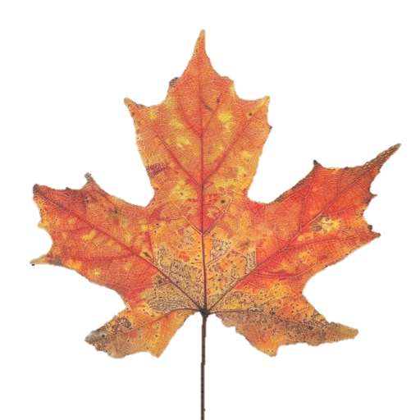
Dessert
- CARAMEL APPLE COOKIES
- TOASTED MARSHMALLOW
- PUMKIN HONEY BUN CAKE


Drinks
- APPLE ORCHID FIZZ

- TANGERINE GINGER SPARKLER
- ELDERBERRY ROSE SPRITZ





VISIT AGAIN

